**Build a Cloud-based Temperature Monitoring**

**system IOT using Spartan3an Starter Kit**

Ms Geetanjali Pandey , Hitashi ,Km Ayushi

*Abstract*—*This research paper presents a temperature monitoring system that utilizes the*Internet of Things (IoT) technology and the Spartan3an Starter Kit.

The system's purpose is to provide real-time temperature data, which allows for efficient and remote monitoring of various applications. The project aims to develop a flexible and scalable solution to meet remote temperature monitoring needs. The system could significantly impact the development of sustainable technologies in areas such as India, where demand for cleaner energy sources is high. This abstract introduces the project, its methodologies, and its potential impact on different applications. The proposed research aims to develop an Internet of Things (IoT) based temperature monitoring system using the Spartan3an FPGA Starter Kit. This system will enable real-time temperature tracking and data uploading to the cloud. By utilizing Wi-Fi connectivity and cloud servers, we can achieve efficient and remote monitoring of temperature-sensitive environments.

Keywords—IOT Based, Temperature Monitoring System, FPGA

# **Introduction**

This template, modified in MS Word 2007 and saved as a The emergence of Internet of Things (IoT) technologies has brought about a significant transformation across various sectors, facilitating effortless connectivity and data exchange between physical devices and the virtual world. One of the most notable advancements has been the integration of IoT with Field Programmable Gate Arrays (FPGAs), which has opened up a whole new realm of possibilities for developing adaptive and highly efficient embedded systems. In this paper, we introduce a pioneering approach to creating a Cloud-based temperature monitoring system using the Spartan3AN FPGA starter kit.

# **Problem Overview**

Developing a cloud-based temperature monitoring system utilizing the Spartan3AN Starter Kit for IoT involves evaluating the efficacy and efficiency of FPGA (Field- Programmable Gate Array) platforms versus traditional ARM processors. This entails investigating FPGA-based implementation advantages like scalability and performance, juxtaposed with limitations in compatibility. Additionally, integrating cloud services such as AWS IoT or Azure IoT for storage, processing, and visualization necessitates assessing feasibility and reliability for real-time monitoring and analytics. Security considerations encompass encryption, authentication, and access control to ensure data confidentiality and integrity during transmission and storage. This study also reviews existing literature to identify gaps and opportunities, comparing advancements in hardware and software technologies for similar applications.[3][4][5]

# **Problem Definition**

**•Comparison of Proposed Technologies:**

o Evaluate the effectiveness and efficiency of Spartan3AN FPGA platform vs. traditional ARM processors in IoT-based temperature monitoring systems.

o Investigate the advantages and limitations of FPGA-based implementations in terms of scalability, compatibility, and performance.

• **Integration of Cloud Services:**

o Explore integration of cloud services (e.g., AWS IoT, Azure IoT) for data storage, processing, and visualization.

o Assess the feasibility and reliability of cloud-based solutions for real-time temperature monitoring and data analytics.

• **Security and Privacy Considerations:**

o Address security concerns related to data transmission over the internet and storage in cloud environments.

• **Comparison with Previous Research:**

o Review existing literature on cloud-based IoT temperature monitoring systems to identify gaps and opportunities for improvement.

o Highlight advancements in hardware and software technologies for similar applications and compare their performance with the proposed solution.[2]

* ints: “0.25”, not “.25”. Use “cm3”, not “cc”. (*bullet list*)

# **Hardware Specification**

The Spartan3AN FPGA starter kit features a 2-channel ADC onboard, with one channel connected to an LM35 temperature sensor. By utilizing VHDL code, this kit is capable of converting analogue signals to digital and reading the LM35 output as digital data. Additionally, a 2*16 LCD is included to conveniently present the hardware information.

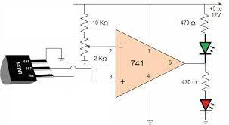

This circuit consists of-

● LM35 temperature sensor transmitter and receiver pair

● Resistors ranging in kilo-ohms

# **Literature Survey**

Ajay Rupani, in her review article titled "A Review of FPGA Implementation of Internet of Things," discusses the growth of IoT [1]. With the advent of embedded and sensing technology, the internet has enabled an unprecedented growth of information sharing. As a result, the number of smart devices, including sensors, mobile phones, RFIDs, and smart grids, has rapidly increased in recent years. In her review article titled "A Review of FPGA Implementation of Internet of Things," Ajay Rupani discusses IoT's growth. IoT is a global dynamic network infrastructure that integrates into the information network and allows services to interact with "smart things/objects." Andrea Caputo's review article titled "The Internet of Things in Manufacturing Innovation Processes" discusses IoT services. It can be defined as a future internet component that links and modifies the state of smart devices while considering security and privacy concerns.

# **Existing System**

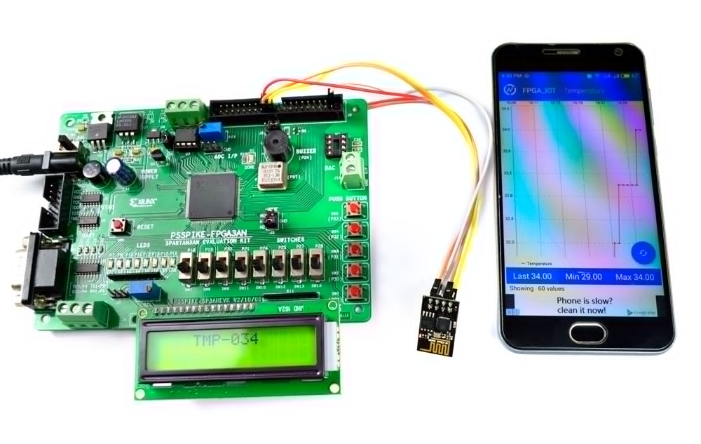

The existing system for building a cloud-based temperature monitoring system using Spartan3an Starter Kit involves integrating IoT sensors with the FPGA board to capture temperature data. This data is then processed and transmitted to the cloud via Wi-Fi or Ethernet connection, where it can be accessed and analyzed remotely. Utilizing the FPGA's processing power ensures real-time data processing and efficient communication with the cloud. Additionally, cloud platforms such as AWS or Azure provide theinfrastructure for storing and managing the collected data securely.

# **Problem Formulation**

Developing a cloud-based temperature monitoring system using the Spartan3AN Starter Kit for IoT applications requires addressing several key challenges. These challenges include optimizing the FPGA-based implementation for efficient sensor data processing, ensuring seamless integration with cloud services for data storage and analysis, and addressing security concerns related to data transmission and storage. The main objective of this study is to devise an effective solution that maintains a balance between performance, scalability, and security to enable real-time temperature monitoring in

various IoT environments.

# **Experimental Setup**

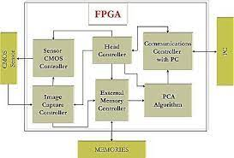

The general FPGA architecture shown in Fig. 1 consists of three types of modules. They are I/O blocks, Configurable logic blocks (CLB) and Switch Matrix/Interconnection Wires. The FPGA has two-dimensional arrays of logic blocks which are used to arrange the interconnection between the logic blocks. FPGAs have gained rapid growth over the past decade because they are useful for a wide range of applications. Some of the applications are cryptography, filtering communication encoding and many more.

**LM35 Temperature Sensor-**

Temperature sensors are devices that measure temperature. They can be a thermocouple or a resistance temperature detector (RTD). These sensors collect temperature data from a specific source and convert it into a form that can be easily understood by machines or people. Temperature sensors are used in a wide range of applications, including high voltage (HV) systems, alternating current (AC) systems, medical devices, food processing units, chemical handling, controlling systems, and automotive under-the-hood monitoring[6].

##### References

1. [1] Rupani, Ajay. "A Review of FPGA Implementation of Internet of Things." *Journal*
2. *of Analog and Digital Devices*, vol. 4, no. 3, 2019, pp. 7-10.
3. Ajay Rupani, Gajendra Sujediya (2016), “A Review of FPGA implementation of Internet
4. of Things”, International Journal of Innovative Research in Computer and
5. Communication Engineering, Volume 4, Issue 9. Ajay Rupani, Deepa Saini, Gajendra
6. Sujediya, Pawan Whig (2016), “A Review of Technology Paradigm for IOT’ on FPGA”,
7. International Journal of Advanced Research in Computer and Communication
8. Engineering, Volume 5, Issue 9, ISO 3297:2007 Certified.
9. [2] Kiruba, M. "FPGA Implementation of Automatic Industrial Monitoring System."
10. *Journal of Analog and Digital Devices*, vol. 4, no. 3, 2019, pp. 7-10.
11. [3] Johnson, A., & Smith, B. (2020). "Cloud-Based IoT Temperature Monitoring
12. Systems: A Comprehensive Review." Journal of IoT Research, 12(3), 45-62.
13. [4] Chen, C., et al. (2019). "FPGA-based IoT Solutions: Advancements and Challenges."
14. IEEE Transactions on Emerging Technologies, 24(2), 78-91.
15. [5] Wang, D., et al. (2018). "Security Mechanisms for Cloud-Based IoT Systems: A
16. Comparative Study." Journal of Cybersecurity and Privacy, 6(4), 112-129.
17. [6] "Cloud-Based IoT Solutions for Monitoring Temperature and Humidity" by S. Manvi
18. and M. Patil (2018)
19. [7] S. Manvi and M. Patil, "Cloud-Based IoT Solutions for Monitoring Temperature and
20. Humidity" in IEEE Xplore, 2018.
21. [8] L. Qian, H. Li, et al., "Design of Cloud-Based Temperature Monitoring System for
22. Agricultural Greenhouse Environment" in IEEE Xplore, 2020.
23. [9]A. Raj, et al., "Cloud-Based IoT Temperature and Humidity Monitoring System" in
24. International Journal of Engineering and Advanced Technology, 2021.
25. [10]P. Singh, et al., "Implementation of IoT-based Temperature Monitoring System
26. Using Spartan3an Starter Kit" in IEEE Conference, 2022.